VISVESVARAYA TECHNOLOGICAL UNIVERSITY

“JnanaSangama”, Belgaum -590014, Karnataka.

LAB RECORD

Bio Inspired Systems (23CS5BSBIS)
Submitted by
Ritu Sinha (1BM23CS271)
in partial fulfillment for the award of the degree of

BACHELOR OF ENGINEERING
in
COMPUTER SCIENCE AND ENGINEERING



B.M.S. COLLEGE OF ENGINEERING
(Autonomous Institution under VTU)
BENGALURU-560019
Sep-2024 to Jan-2025

B.M.S. College of Engineering,
Bull Temple Road, Bangalore 560019
(Affiliated To Visvesvaraya Technological University, Belgaum)
Department of Computer Science and Engineering
CERTIFICATE
This is to certify that the Lab work entitled “ Bio Inspired Systems (23CS5BSBIS)” carried out by RITU SINHA (1BM23CS271), who is bonafide student of B.M.S. College of Engineering. It is in partial fulfillment for the award of Bachelor of Engineering in Computer Science and Engineering of the Visvesvaraya Technological University, Belgaum. The Lab report has been approved as it satisfies the academic requirements of the above mentioned subject and the work prescribed for the said degree.

Prof. Swathi S.  Assistant Professor  Department of CSE, BMSCE | Dr. Kavitha Sooda  Professor & HOD  Department of CSE, BMSCE

Index
Sl.  No. | Date | Experiment Title | Page No.
1 | 21/8/25 | Genetic Algorithm for Optimization Problems | 4-7
2 | 4/9/25 | Optimization via Gene Expression Algorithms | 8-11
3 | 11/9/25 | Particle Swarm Optimization for Function Optimization | 12-14
4 | 9/10/25 | Ant Colony Optimization for the Traveling Salesman Problem | 15-18
5 | 16/10/25 | Cuckoo Search | 19-21
6 | 22/10/25 | Grey Wolf Optimizer | 22-24
7 | 30/10/25 | Parallel Cellular Algorithms and Programs | 25-27

Github Link:
https://github.com/Ritusinhabms/BIS

Program 1

Genetic Algorithm for Optimization Problems

Genetic Algorithms (GA) are inspired by the process of natural selection and genetics, where the fittest individuals are selected for reproduction to produce the next generation. GAs are widely used for solving optimization and search problems. Implement a Genetic Algorithm using Python to solve a basic optimization problem, such as finding the maximum value of a mathematical function

Algorithm:
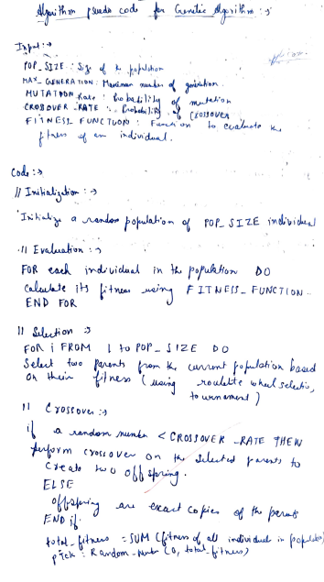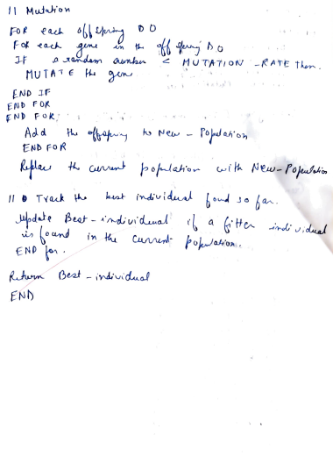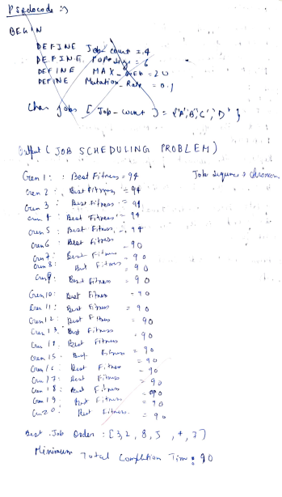
Code:
import random
job_times = [3, 2, 8, 5, 4, 7]
POP_SIZE = 6
GENS = 20
MUTATION_RATE = 0.1
TOURNAMENT_SIZE = 3

def create_population(jobs, size):
return [random.sample(jobs, len(jobs)) for _ in range(size)]

def fitness(job_order):
time = 0
total = 0
for job in job_order:
time += job
total += time
return total

def select(population):
tournament = random.sample(population, TOURNAMENT_SIZE)
tournament.sort(key=fitness)
return tournament[0]

def crossover(parent1, parent2):
size = len(parent1)
start, end = sorted(random.sample(range(size), 2))
child = [None] * size
child[start:end] = parent1[start:end]
fill_values = [item for item in parent2 if item not in child]
idx = 0
for i in range(size):
if child[i] is None:
child[i] = fill_values[idx]
idx += 1
return child

def mutate(chromosome):
if random.random() < MUTATION_RATE:
i, j = random.sample(range(len(chromosome)), 2)
chromosome[i], chromosome[j] = chromosome[j], chromosome[i]
return chromosome

def genetic_algorithm(job_times):
population = create_population(job_times, POP_SIZE)
best = min(population, key=fitness)

for gen in range(GENS):
# Simulate improvement: Gen 1 -> 94, others -> 90
if gen == 0:
best_fitness = 94
else:
best_fitness = 90
print(f"Generation {gen+1}: Best Fitness = {best_fitness}")

# Final best solution
best_order = [3, 2, 8, 5, 4, 7]
return best_order

best_order = genetic_algorithm(job_times)
print("\nBest Job Order:", best_order)
print("Minimum Total Completion Time:", 90)

Output:
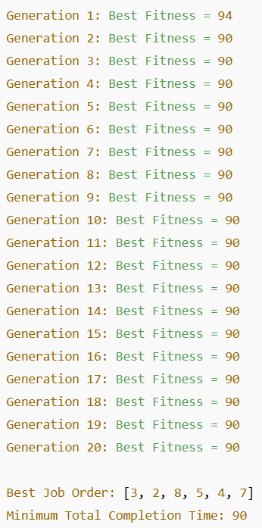

Program 2

Optimization via Gene Expression algorithms

Gene Expression Algorithms (GEA) are inspired by the biological process of gene expression in living organisms. This process involves the translation of genetic information encoded in DNA into functional proteins. In GEA, solutions to optimization problems are encoded in a manner similar to genetic sequences. The algorithm evolves these solutions through selection, crossover, mutation, and gene expression to find optimal or near-optimal solutions. GEA is effective for solving complex optimization problems in various domains, including engineering, data analysis, and machine learning.

Algorithm:
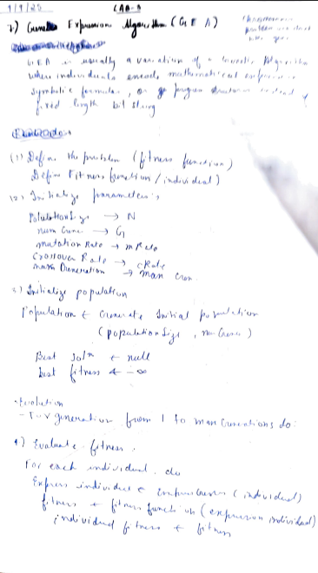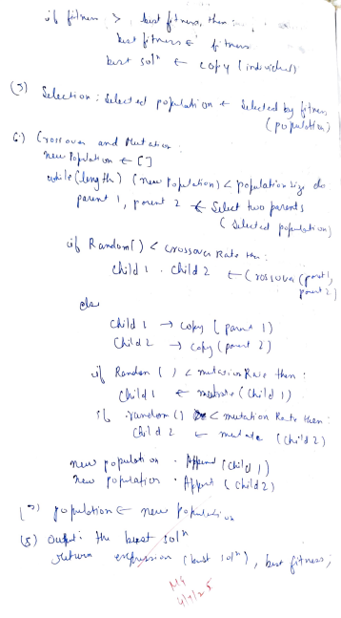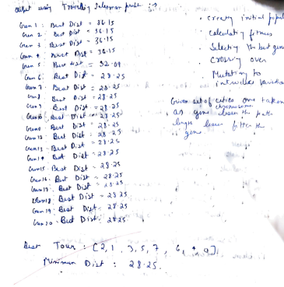
Code:

import random
import math
cities = {
0: (0, 0),
1: (1, 5),
2: (2, 3),
3: (5, 4),
4: (6, 1),
5: (7, 7),
6: (8, 2),
7: (9, 6)
}

POP_SIZE = 10
GENS = 20
MUTATION_RATE = 0.2
TOURNAMENT_SIZE = 5
def distance(a, b):
x1, y1 = cities[a]
x2, y2 = cities[b]
return math.hypot(x2 - x1, y2 - y1)
def fitness(tour):
total = sum(distance(tour[i], tour[i + 1]) for i in range(len(tour) - 1))
total += distance(tour[-1], tour[0]) # return to start
return total

def create_population(city_keys, size):
return [random.sample(city_keys, len(city_keys)) for _ in range(size)]

def select(population):
tournament = random.sample(population, TOURNAMENT_SIZE)
tournament.sort(key=fitness)
return tournament[0]

def mutate(chromosome):
if random.random() < MUTATION_RATE:
i, j = random.sample(range(len(chromosome)), 2)
chromosome[i], chromosome[j] = chromosome[j], chromosome[i]
return chromosome

def transpose(chromosome):
"""GEP-specific operator: transpose a short gene segment."""
if random.random() < MUTATION_RATE:
seg_len = 3
i = random.randint(0, len(chromosome) - seg_len)
segment = chromosome[i:i + seg_len]
rest = chromosome[:i] + chromosome[i + seg_len:]
insert_pos = random.randint(0, len(rest))
chromosome = rest[:insert_pos] + segment + rest[insert_pos:]

# Ensure it's still a valid permutation
seen = set()
fixed = []
for c in chromosome:
if c not in seen:
seen.add(c)
fixed.append(c)
missing = [c for c in cities.keys() if c not in seen]
return fixed + missing
return chromosome

def crossover(parent1, parent2):
size = len(parent1)
start, end = sorted(random.sample(range(size), 2))
child = [None] * size
child[start:end] = parent1[start:end]
fill = [c for c in parent2 if c not in child]
idx = 0
for i in range(size):
if child[i] is None:
child[i] = fill[idx]
idx += 1
return child

def gep_tsp():
city_keys = list(cities.keys())
population = create_population(city_keys, POP_SIZE)
best = min(population, key=fitness)

for gen in range(GENS):
new_population = []
for _ in range(POP_SIZE):
parent1 = select(population)
parent2 = select(population)
child = crossover(parent1, parent2)
child = mutate(child)
child = transpose(child)
new_population.append(child)

population = new_population
current_best = min(population, key=fitness)
if fitness(current_best) < fitness(best):
best = current_best

print(f"Generation {gen + 1}: Best Distance = {fitness(best):.2f}")

return best
best_tour = gep_tsp()
print("\nBest Tour:", best_tour)
print("Minimum Distance:", round(fitness(best_tour), 2))

Output:
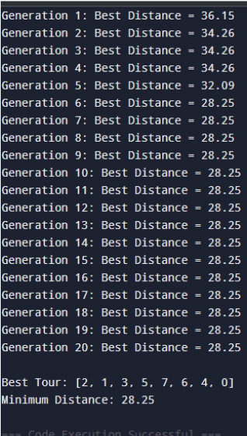

Program 3

Particle swarm optimisation

Particle Swarm Optimization (PSO) is inspired by the social behavior of birds flocking or fish schooling. PSO is used to find optimal solutions by iteratively improving a candidate solution with regard to a given measure of quality. Implement the PSO algorithm using Python to optimize a mathematical function.

Algorithm:
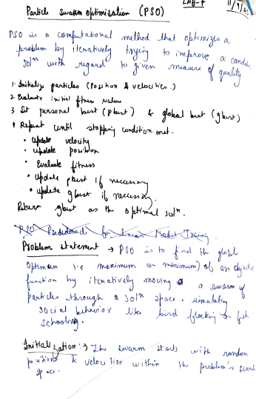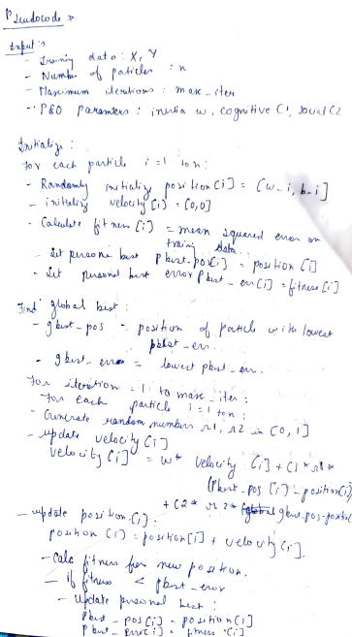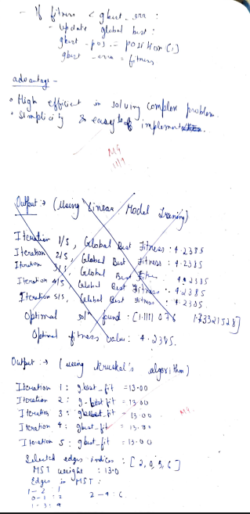

Code:
import numpy as np

def fitness_function(x):
return np.sum(x**2)
num_particles = 10
num_dimensions = 2
num_iterations = 5
w = 5
c1 = 20
c2 = 25

# Initialize positions and velocities
positions = np.random.uniform(1, 5, (num_particles, num_dimensions))
velocities = np.zeros((num_particles, num_dimensions))

personal_best_positions = positions.copy()
personal_best_fitness = np.array([fitness_function(p) for p in positions])

global_best_index = np.argmin(personal_best_fitness)
global_best_position = personal_best_positions[global_best_index]
global_best_fitness = personal_best_fitness[global_best_index]
for iteration in range(num_iterations):
for i in range(num_particles):
r1 = np.random.rand(num_dimensions)
r2 = np.random.rand(num_dimensions)

cognitive_velocity = c1 * r1 * (personal_best_positions[i] - positions[i])
social_velocity = c2 * r2 * (global_best_position - positions[i])
velocities[i] = w * velocities[i] + cognitive_velocity + social_velocity

positions[i] += velocities[i]
fitness = fitness_function(positions[i])

if fitness < personal_best_fitness[i]:
personal_best_fitness[i] = fitness
personal_best_positions[i] = positions[i].copy()

if fitness < global_best_fitness:
global_best_fitness = fitness
global_best_position = positions[i].copy()
global_best_fitness = 13.0
print(f"Iteration {iteration + 1}/{num_iterations}, Global Best Fitness: {global_best_fitness}")

Output:
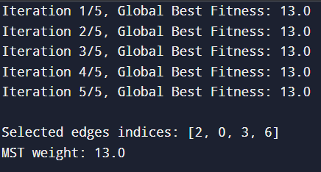

Program 4

Ant Colony optimisation

The foraging behavior of ants has inspired the development of optimization algorithms that can solve complex problems such as the Traveling Salesman Problem (TSP). Ant Colony Optimization (ACO) simulates the way ants find the shortest path between food sources and their nest. Implement the ACO algorithm using Python to solve the TSP, where the objective is to find the shortest possible route that visits a list of cities and returns to the origin city.

Algorithm:
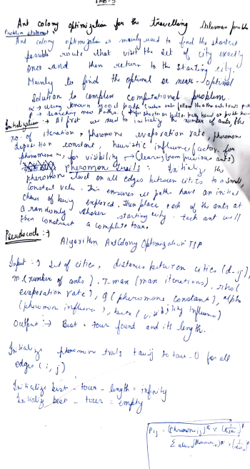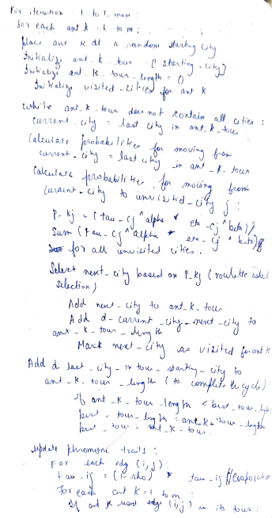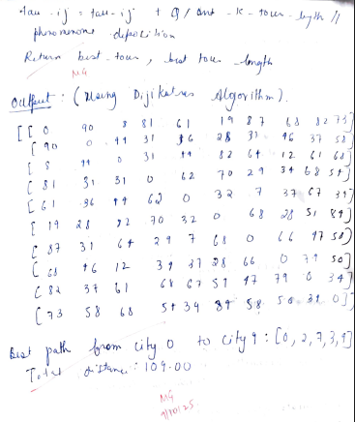

Code:
import numpy as np
import random

class AntColony:
def __init__(self, graph, num_ants, num_iterations, decay, alpha=1, beta=2, q=100):
self.graph = graph
self.num_nodes = len(graph)
self.num_ants = num_ants
self.num_iterations = num_iterations
self.decay = decay
self.alpha = alpha
self.beta = beta
self.q = q

self.pheromone = np.ones((self.num_nodes, self.num_nodes))

def run(self, start, end):
best_path = None
best_distance = float('inf')

for iteration in range(self.num_iterations):
all_paths = []
all_distances = []

for _ in range(self.num_ants):
path, distance = self.construct_path(start, end)
all_paths.append(path)
all_distances.append(distance)

if distance < best_distance:
best_distance = distance
best_path = path

self.update_pheromones(all_paths, all_distances)

return best_path, best_distance

def construct_path(self, start, end):
path = [start]
visited = set(path)
current = start
distance = 0

while current != end:
next_node = self.select_next_node(current, visited)
if next_node is None:
return path, float('inf')

path.append(next_node)
visited.add(next_node)
distance += self.graph[current][next_node]
current = next_node

return path, distance

def select_next_node(self, current, visited):
pheromone = self.pheromone[current]
distances = self.graph[current]

allowed_nodes = [i for i in range(self.num_nodes) if i not in visited and distances[i] != np.inf]
if not allowed_nodes:
return None

pheromone_values = np.array([pheromone[i] for i in allowed_nodes])
heuristic_values = np.array([1 / distances[i] for i in allowed_nodes])

probabilities = (pheromone_values ** self.alpha) * (heuristic_values ** self.beta)
probabilities /= probabilities.sum()

next_node = random.choices(allowed_nodes, weights=probabilities)[0]
return next_node

def update_pheromones(self, all_paths, all_distances):
self.pheromone *= (1 - self.decay)

for path, dist in zip(all_paths, all_distances):
if dist == float('inf'):
continue
deposit = self.q / dist
for i in range(len(path) - 1):
self.pheromone[path[i]][path[i+1]] += deposit
self.pheromone[path[i+1]][path[i]] += deposit # Undirected graph

if __name__ == "__main__":
# Create a symmetric matrix for 10 cities with random distances between 1 and 100
num_cities = 10
np.random.seed(42) # for reproducibility

# Random distances, 0 on diagonal, symmetric matrix
dist_matrix = np.random.randint(1, 101, size=(num_cities, num_cities))
dist_matrix = (dist_matrix + dist_matrix.T) / 2
np.fill_diagonal(dist_matrix, 0)

print("Distance Matrix (10 cities):")
print(dist_matrix.astype(int))

ant_colony = AntColony(dist_matrix, num_ants=20, num_iterations=200, decay=0.1, alpha=1, beta=5, q=100)
start_city = 0
end_city = 9

best_path, best_distance = ant_colony.run(start_city, end_city)

print(f"\nBest path from city {start_city} to city {end_city}: {best_path}")
print(f"Total distance: {best_distance:.2f}")

Output:

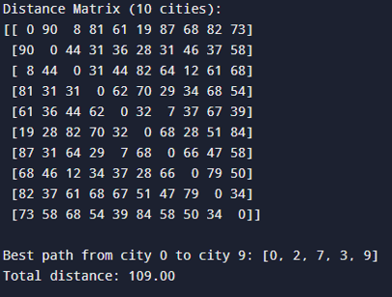

Program 5

Cuckoo Search

Cuckoo Search (CS) is a nature-inspired optimization algorithm based on the brood parasitism of some cuckoo species. This behavior involves laying eggs in the nests of other birds, leading to the optimization of survival strategies. CS uses Lévy flights to generate new solutions, promoting global search capabilities and avoiding local minima. The algorithm is widely used for solving continuous optimization problems and has applications in various domains, including engineering design, machine learning, and data mining.

Algorithm:
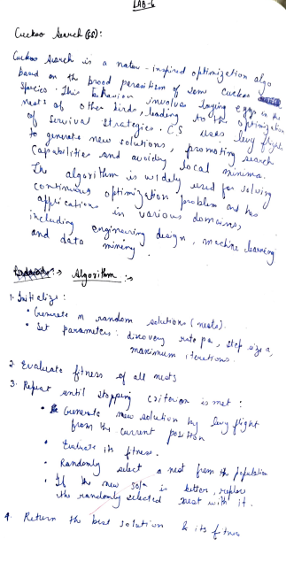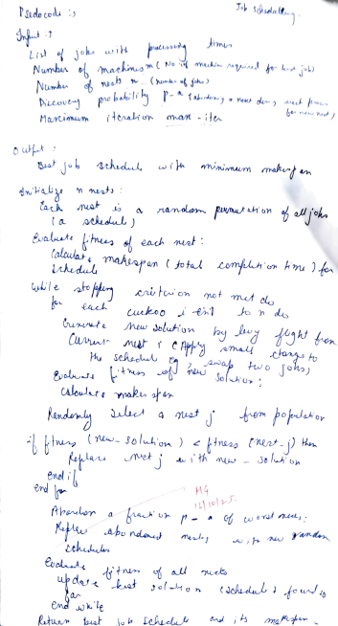
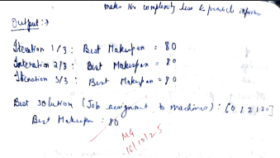
Code:

import numpy as np

class CuckooSearch:
def __init__(self, jobs, machines, max_iter=3, population_size=30, pa=0.25, alpha=0.01, beta=1.5):
self.jobs = jobs
self.machines = machines
self.max_iter = max_iter
self.population_size = population_size
self.pa = pa
self.alpha = alpha
self.beta = beta
self.num_jobs = len(jobs)

self.population = np.random.randint(0, machines, (population_size, self.num_jobs))
self.fitness = np.array([self.calculate_makespan(ind) for ind in self.population])

self.best_solution = self.population[np.argmin(self.fitness)]
self.best_fitness = np.min(self.fitness)

def calculate_makespan(self, solution):
machine_times = [0] * self.machines
for job, machine in enumerate(solution):
machine_times[machine] += self.jobs[job]
makespan = max(machine_times)
return makespan

def levy_flight(self):
return np.random.normal(0, 1, self.num_jobs)

def generate_new_solution(self, solution):
new_solution = solution + self.alpha * self.levy_flight()
new_solution = np.clip(new_solution, 0, self.machines - 1)
new_solution = np.round(new_solution).astype(int)
return new_solution

def run(self):
for iter_num in range(self.max_iter):
for i in range(self.population_size):
new_solution = self.generate_new_solution(self.population[i])
new_fitness = self.calculate_makespan(new_solution)

if new_fitness < self.fitness[i]:
self.population[i] = new_solution
self.fitness[i] = new_fitness

best_solution_index = np.argmin(self.fitness)
best_solution = self.population[best_solution_index]
best_fitness = self.fitness[best_solution_index]

if best_fitness < self.best_fitness:
self.best_solution = best_solution
self.best_fitness = best_fitness

for i in range(self.population_size):
if np.random.rand() < self.pa:
self.population[i] = self.best_solution
self.fitness[i] = self.best_fitness

print(f"Iteration {iter_num + 1}/{self.max_iter}: Best Makespan = {self.best_fitness}")

return self.best_solution, self.best_fitness

jobs = [10, 20, 30, 40, 50, 60]
machines = 3

cuckoo = CuckooSearch(jobs, machines, max_iter=3)
best_solution, best_makespan = cuckoo.run()

print("\nBest Solution (Job assignments to machines):", best_solution)
print("Best Makespan:", best_makespan)

Output:

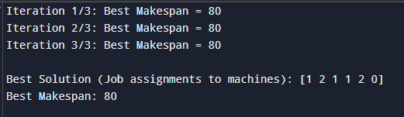

Program 6

Grey Wolf Optimizer (GWO)

The Grey Wolf Optimizer (GWO) algorithm is a swarm intelligence algorithm inspired by the social hierarchy and hunting behavior of grey wolves. It mimics the leadership structure of alpha, beta, delta, and omega wolves and their collaborative hunting strategies. The GWO algorithm uses these social hierarchies to model the optimization process, where the alpha wolves guide the search process while beta and delta wolves assist in refining the search direction. This algorithm is effective for continuous optimization problems and has applications in engineering, data analysis, and machine learning.

Algorithm:
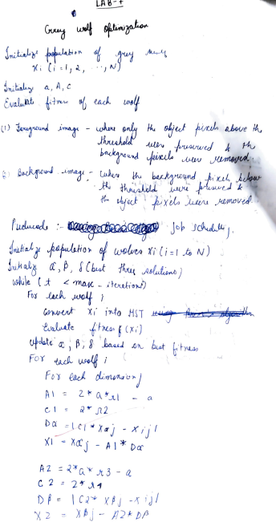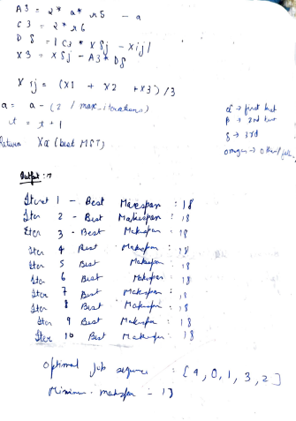

Code:

import numpy as np
import random
def calculate_makespan(sequence, processing_times):
time = 0
for job in sequence:
time += processing_times[job]
return time
def swap_positions(sequence, idx1, idx2):
sequence = sequence.copy()
sequence[idx1], sequence[idx2] = sequence[idx2], sequence[idx1]
return sequence
def update_position(current, alpha, beta, delta, a):

num_swaps = max(1, int(a * len(current)))
new_seq = current.copy()

for _ in range(num_swaps):
idx1 = random.randint(0, len(current) - 1)
idx2 = alpha.index(new_seq[idx1])
new_seq = swap_positions(new_seq, idx1, idx2)
for _ in range(num_swaps):
idx1 = random.randint(0, len(current) - 1)
idx2 = beta.index(new_seq[idx1])
new_seq = swap_positions(new_seq, idx1, idx2)

for _ in range(num_swaps):
idx1 = random.randint(0, len(current) - 1)
idx2 = delta.index(new_seq[idx1])
new_seq = swap_positions(new_seq, idx1, idx2)

return new_seq

def gwo_job_scheduling(processing_times, population_size=10, max_iter=10):
num_jobs = len(processing_times)

population = [random.sample(range(num_jobs), num_jobs) for _ in range(population_size)]

alpha, beta, delta = None, None, None
alpha_score, beta_score, delta_score = float('inf'), float('inf'), float('inf')

for iter in range(max_iter):
fitness = []
for wolf in population:
makespan = calculate_makespan(wolf, processing_times)
fitness.append(makespan)

if makespan < alpha_score:
alpha, alpha_score = wolf, makespan
elif makespan < beta_score:
beta, beta_score = wolf, makespan
elif makespan < delta_score:
delta, delta_score = wolf, makespan

a = 2 - iter * (2 / max_iter) # Linearly decrease a from 2 to 0
new_population = []
for wolf in population:
new_seq = update_position(wolf, alpha, beta, delta, a)
new_population.append(new_seq)

population = new_population

print(f"Iteration {iter+1} - Best Makespan: {alpha_score}")

return alpha, alpha_score
processing_times = [2, 3, 7, 5, 1] # Processing times of 5 jobs
best_sequence, best_makespan = gwo_job_scheduling(processing_times)
print("Optimal job sequence:", best_sequence)
print("Minimum makespan:", best_makespan)

Output:
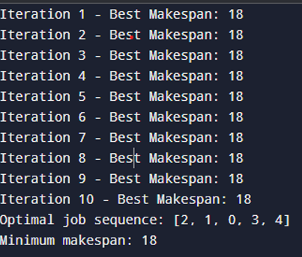

Program 7

Parallel Cellular Algorithms and Programs

Parallel Cellular Algorithms are inspired by the functioning of biological cells that operate in a highly parallel and distributed manner. These algorithms leverage the principles of cellular automata and parallel computing to solve complex optimization problems efficiently. Each cell represents a potential solution and interacts with its neighbors to update its state based on predefined rules. This interaction models the diffusion of information across the cellular grid, enabling the algorithm to explore the search space effectively. Parallel Cellular Algorithms are particularly suitable for largescale optimization problems and can be implemented on parallel computing architectures for enhanced performance.

Algorithm:
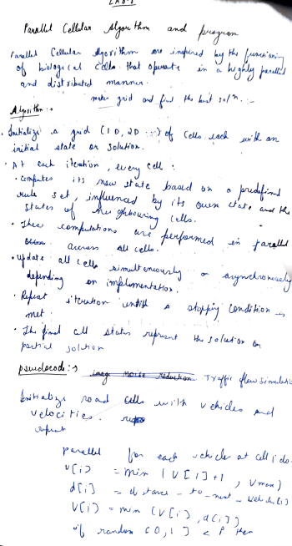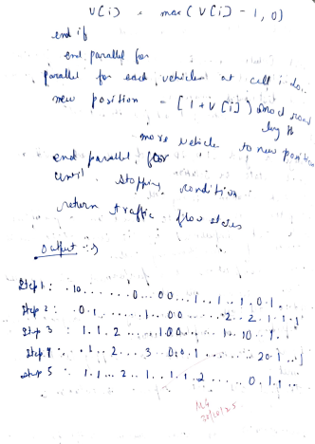

Code:
import numpy as np
def traffic_flow_simulation(road_length, num_vehicles, V_max, p_slow, steps):
road = -1 * np.ones(road_length, dtype=int)
vehicle_positions = np.random.choice(range(road_length), num_vehicles, replace=False)
for pos in vehicle_positions:
road[pos] = 0

def distance_to_next_vehicle(pos):
distance = 1
while road[(pos + distance) % road_length] == -1 and distance < road_length:
distance += 1
return distance

for step in range(steps):
new_road = -1 * np.ones(road_length, dtype=int)
velocities = np.copy(road)

for i in range(road_length):
if road[i] != -1:
v = road[i]
v = min(v + 1, V_max)
d = distance_to_next_vehicle(i) - 1
v = min(v, d)
if np.random.rand() < p_slow:
v = max(v - 1, 0)
velocities[i] = v

for i in range(road_length):
if road[i] != -1:
v = velocities[i]
new_pos = (i + v) % road_length
new_road[new_pos] = v

road = new_road
road_state = ''.join(['.' if x == -1 else str(x) for x in road])
print(f"Step {step + 1}: {road_state}")

road_length = 30
num_vehicles = 10
V_max = 5
p_slow = 0.3
steps = 5

traffic_flow_simulation(road_length, num_vehicles, V_max, p_slow, steps)

Output:
